2019
August 21, 28, September 4, 18, 24 and October 2
Wirth Loppet Trailhead & MN State Fair Grandstand
Pay close attention to the nightly start times and venues. Start times will get earlier as the daylight decreases. These races will be organized, structured and low-key early season races. This is a great time to try the sport out as a Newbie or Beginner and for the returning racers this gives you a chance to work out the cobwebs and knock off the rust. The races will be insured, but not through USA Cycling. Newbies and Beginners will have a chance to try racing without worrying about USAC one day license fees. Self-selecting fields…pick your own race. (No sand bagging) If you have any racing experience and are new to CX start with the Beginner field. If you have never raced, then the Newbies is a good place to start. Advanced 60 minutes, Intermediate 45 minutes, Beginners 30 minutes and Newbies roll for 15 minutes. This is a professionally chip timed series-cost to replace lost chip is $110. Return chip to blue bucket when finished with your race.
START TIMES: These will change each week, please read flyer and don’t be late. Registration begins one hour before the first race and ends 15 minutes prior to race start. Check www.EndurancePromotions.com for bib placement during race afternoon. Keep your bib number for entire series.

This race series is not a USA Cycling series, meaning results will not be sent to USA Cycling. There will be no USAC points to earn. We will have trained officials there keeping order and keeping things safe. You do not need a USA Cycling license to race. Newbies are people who have not raced before. Beginners will be grouped with Juniors. Intermediate race is for Cat 4 Cat 5 racers and Advanced race is for Cat 1/2/3 racers. Masters can self- seed based on length of race and category.

2019 Race Schedule
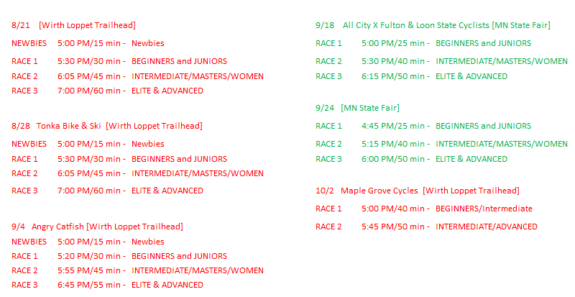

Locations
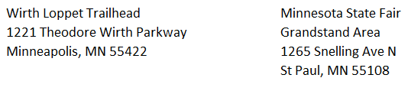
SHOPS and TEAMS

